**Задание № 1**

select g.name as имя_товара, value as цена_товара

from prices

join goods g on prices.goods_id = g.id

where value = ALL (

select max(value)

from prices

)

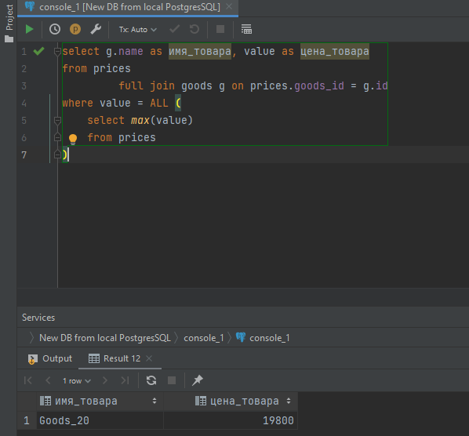

**Задание №2**

select g.name as имя_товара, p.value цена_товара

from prices

join goods g on g.id = prices.goods_id

join prices p on g.id = p.goods_id

join quantity q on g.id = q.goods_id

where q.value = 0

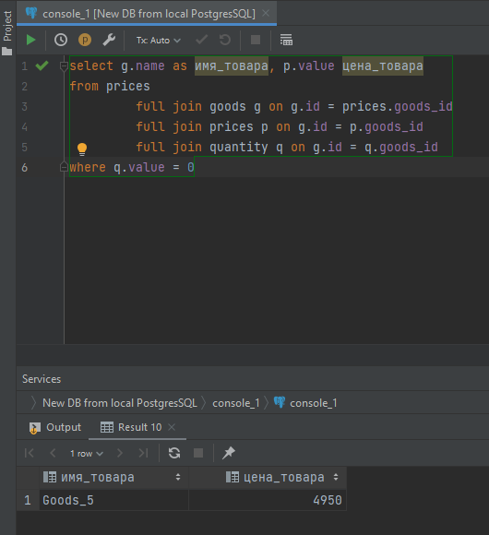

**Задание №3**

select m.name as имя_производителя, avg(value) AS средняя_стоимость

from prices

join goods g on g.id= prices.goods_id

join suppliers s on g.supplier_id = s.id

join manufacturer m on s.manufacturer_id = m.id

group by m.name

having avg(value) >= all(

select avg(value) from prices

join goods g on g.id= prices.goods_id

join suppliers s on g.supplier_id = s.id

join manufacturer m on s.manufacturer_id = m.id

group by m.name

)

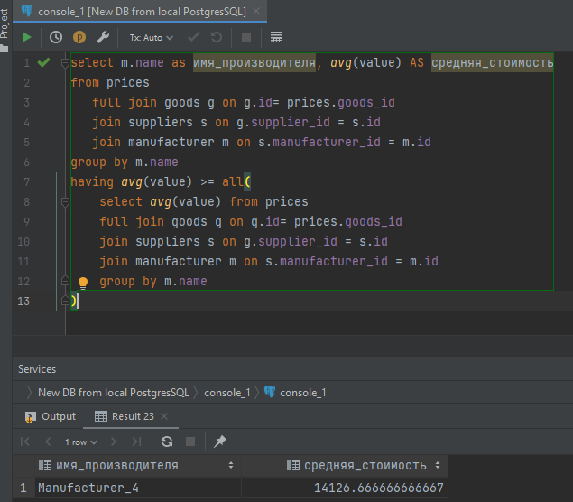

**Задание № 4**

select g.name as имя_товара, value as цена_товара, m.name as имя_производителя

from prices

join goods g on g.id = prices.goods_id

join suppliers s on g.supplier_id = s.id

join manufacturer m on s.manufacturer_id = m.id

where m.location = 'Moscow'

